

Feb 21, 2012

# Torshi-e Piaz (Red Onion and Herb Pickles)

These tarragon-flavored pickles pair well with Iranian meatballs and other meat dishes. This recipe first appeared in our March 2012 issue, with Anissa Helou's story The Land of Bread and Spice

(http://www.saveur.com/article/Kitchen/The-Land-of-Bread-and-Spice) .

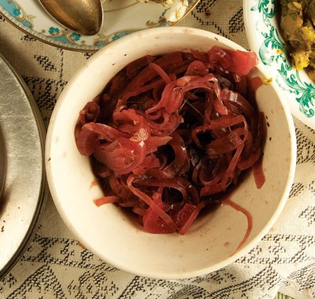MAKES 4 CUPS

INGREDIENTS

3 cups distilled white vinegar

3 tbsp. kosher salt

2 tbsp. dried tarragon

1 tbsp. dried mint

1 tbsp. dried savory

1 tbsp. coriander seeds

1 tbsp. nigella seeds

1 dried chile de arbol (long slim hot chili)

1 lb. red onions, thinly sliced

INSTRUCTIONS

Heat everything but onions in a 4-qt. pan over medium Credit: Todd Coleman heat for 5 minutes. Add onions, and cook until softened, 5–6 minutes. Transfer onions to a 1-qt. glass jar; pour over vinegar. Seal; let sit overnight before serving.